ANNOUNCEMENT (1st round)
3rd IASSRT symposium, Buyeo, Republic of Korea
Silk Road Textiles: Tangible and Intangible Cultural Heritage

I. Description
“Silk Road Textiles: Tangible and Intangible Cultural Heritage” Symposium and 3rd IASSRT meeting will be held from Nov. 5 to Nov. 9, 2018 in Buyeo, the Republic of Korea. The symposium will make in-depth discussion on the important tangible and intangible textile heritages, which have been culturally transmitted along the Silk Road. Heritage such as Korean and Asian textile traditions, textiles on the Eastern Silk Road, textiles on the Steppe Silk Road, textiles along the Maritime Silk Road, Eastern textiles in European collection, and new researches on the Silk Road textiles shall be addressed.

● Host: International Association for the Study of Silk Road Textiles (IASSRT)
● Co-organizers: Korea National University of Culture Heritage, China National Silk Museum
● Co-Chairmen: Sim Yeon-ok, Feng Zhao

II. Program
Nov. 5
- Check in Korea National University of Culture Heritage in Buyeo
Evening:
- Meeting of IASSRT members
Nov. 6
“Silk Road Textiles: Tangible and Intangible Cultural Heritage” Symposium
Morning:
- Opening ceremony
- Panel 1: Korean and Asian Textile Traditions
Afternoon:
- Panel 2: Textiles on the Eastern Silk Road
- Panel 3: Textiles on the Steppe Silk Road
Evening:
- Welcome banquet
Nov. 7
Morning:
- Panel 4: Textiles along the Maritime Silk Road
- Panel 5: Eastern Textiles in European Collection
Afternoon:
- Panel 6: New Research on the Silk Road Textiles
- Visit Transmission hall of Hansan Mosi in Hansan
‘Weaving of Mosi (fine ramie) in the Hansan region’ is inscribed on the Representative List of the Intangible Cultural Heritage of Humanity by UNESCO’
Evening:
- ISU History and Culture Committee members meeting (venue: Lotte Resort Buyeo)
Nov. 8
Morning:
- Visit an exhibition of ‘Textiles from Buddhist Statues Enshrinement’ at
Sudeok Temple Museum in Yesan
- Special lecture
Afternoon:
- Visit an exhibition of ‘Korea and China’s Intangible Cultural Heritage: Silk (working title)’ at National Intangible Heritage Center in Jeonju
- Panel 7: Workshop and Demonstration with Human Treasure, personnel who have been designated as Korean National Intangible Cultural Heritage, regarding ‘Maedeupjang (Decorative Knot Making)’, ‘Jasujang (Embroidery)’, ‘Geumbakjang (Gold Leaf Imprinting)’, ‘Myeongju Jjagi (Silk Weaving)’.
Evening:
- Banquet
Nov. 9
Morning:
- Visit the silk market in Seoul
- Panel 8: Textile conservation at National Museum of Korea in Seoul
Afternoon:
- Visit the gallery at National Museum of Korea
- Visit an exhibition of ‘A Story of Beautiful Color Harmony Showing through the Korean Traditional Clothes (working title)’ at Kyung-woon Museum in Seoul
Evening:
- Closing ceremony
- Farewell dinner
Nov. 10
Departure

<Map of visiting cities>
III. Guest Speaker:
All the scholars of relative fields are welcomed to submit their paper to the symposium. The reply for attending the symposium (see attached) shall be sent to nuch2018@naver.com (or chinasilkmuseum@163.com) before Aug. 1. 2018

IV. Contacts:
Ko Woori: kowoori_nuch@naver.com (Korea)
Irene Lu: irenelu_hz@163.com(China)

V. Fees:
1. Registration fee: USD 100
2. Fee for study tour: (to be decided)

Suggested accommodation (Walking distance from the University):
- Buyeo
Lotte Resort Buyeo
400, Baekjemun-ro, Gyuam-myeon, Buyeo-gun, Chungcheongnam-do, Korea
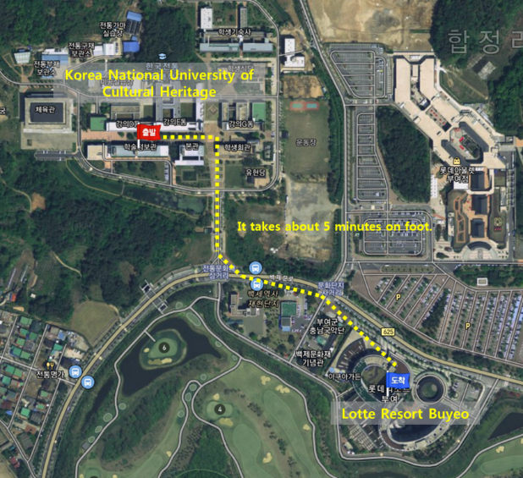
Notes:
● Working language: English
● All the information about accommodation, restaurant and transportation will be finalized by the end of June.
● For more information, please link to:
http://iassrt.org/
http://www.nuch.ac.kr/english/main.do
http://www.chinasilkmuseum.com/

Confirmation Reply

Name |  | Email
Sex |  | Nationality
Institution |  | Professional Title
Topic of Speech*
Abstract of Speech*
Please attach a photocopy of your Passport for invitation letter.
You don’t have to fill in these (*) fields if you do not make any speeches.

